

# A screen shot of a computer screen Description automatically generatedEX1: C function to find the length of string. Output:

Enter a string: Hello Length of the string: 5

Note : The problem here is the null in the array of string

It’s counted with the char.

So, we have two solutions :

1. Use for loop to check if there isn’t a new char so it means next is null -> break.
2. Use str[strcspm] no count without including null

# <https://github.com/George-Emad31/C-Problem_solving/blob/main/ASSign3/1.c>

# EX2: C Function to insert an Element in an Array.

Output:

Enter the number of elements of this array: 6 Enter the Elements: 1 5 6 8 2 4

Enter the element to be inserted in the array: 3

Enter the index of the number: 1

The new Array is: 1 3 6 8 2 4

# EX3: C program to search a bout number in an Array.

Output1:

Enter the number of elements of this array: 6 Enter the Elements: 10 51 68 48 22 43 Enter the number you want to find: 68

The number was found at index 2 Output2:

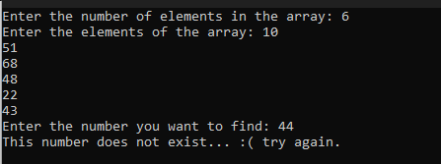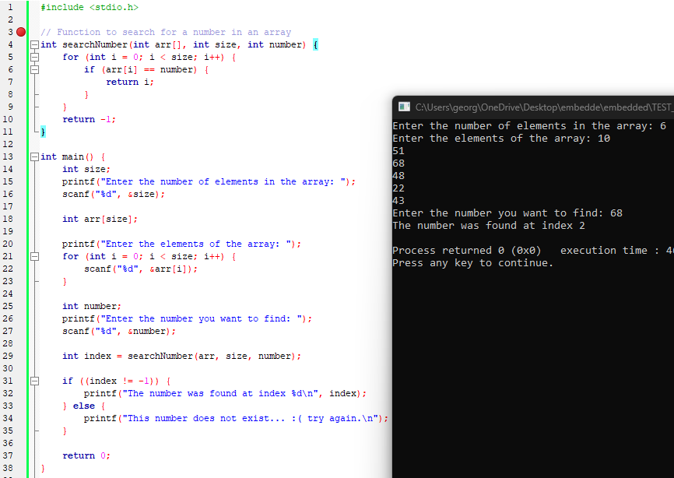Enter the number you want to find: 44 This number does not exist, try again.



**Assignment 03 (Array s String)**

# EX4: write a program to check whether any digits in a number appears more than once:

Output1:

**Enter the number: 14312** ➔ **(in this number 1 is exist twice so it will print yes)**

**yes**

Output2:

**Enter the number: 1432 No**



**EX5: write a program to get the number of elements of this array**

**EX6: predict the output.**

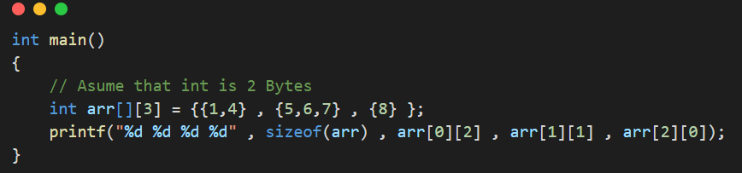

[3*3*2=18] | [0] | [ 6 ] | [ 8 ]